KILN frontend design proposal
  - A professional pottery simulator interface
Prepared for Avivengers | September 2026
Build KILN around the experience of working at a pottery wheel. The clay should dominate the screen, the player should understand every contact and release, and the interface should guide a complete journey from a lump of clay to a finished object.
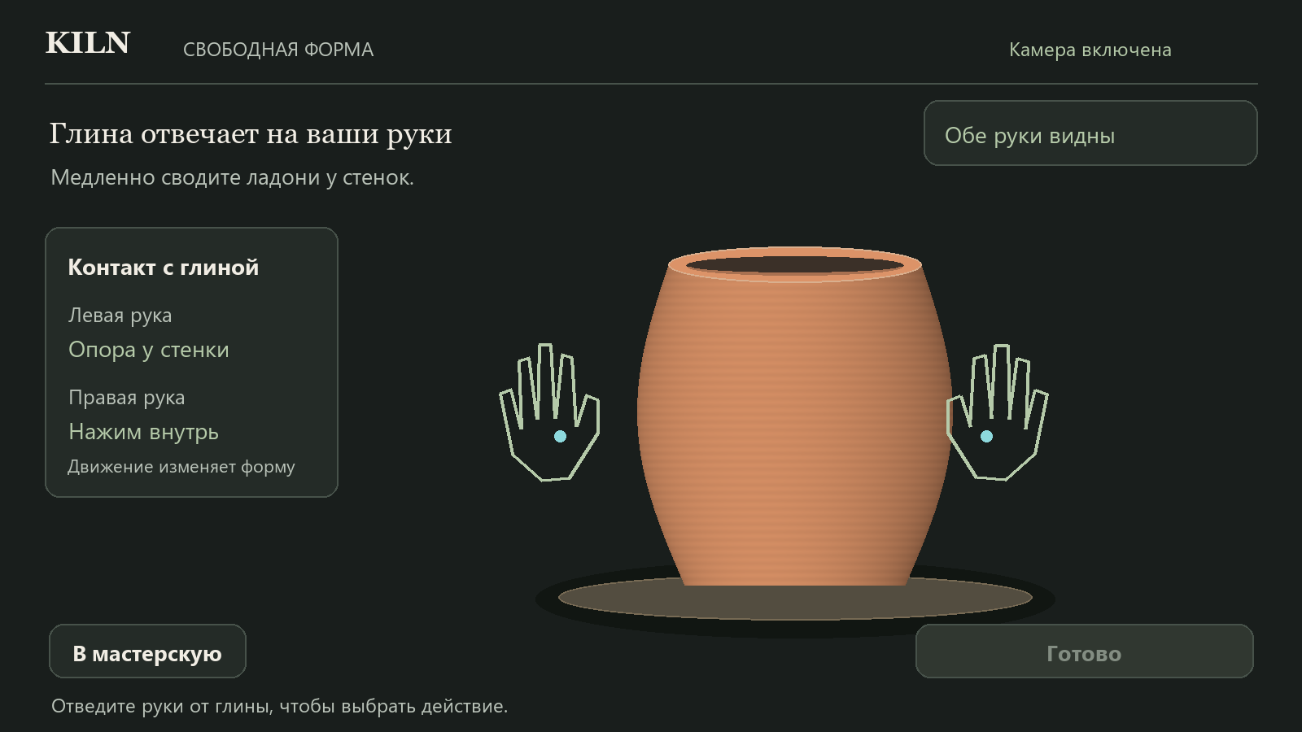
Proposed studio appearance. This concept illustrates hierarchy, materials and interaction feedback.

Recommended direction
Use a dark mineral background, warm clay, soft directional light and quiet sage controls. Put the active instruction above the clay stage and keep secondary information at its edges. Reserve cyan for target geometry and amber for gesture preparation. The result should feel like a crafted game environment with clear instrument readouts.
This proposal covers the main menu, camera setup, free and reference sculpting, lessons, gesture feedback, damage, glazing, firing, the collection, accessibility and delivery priorities. The proposed interface keeps the existing five pottery functions and the explicit Готово finishing action.
  - DESIGN PROPOSAL 02

Visual identity and design system
The visual language should combine a contemporary ceramic studio with the restraint of a well-designed instrument panel. Use a matte charcoal canvas, small changes in surface elevation and a consistent light source. Texture belongs primarily on the clay and wheel; keep reading surfaces smooth.
Role | Proposed value | Use
Canvas | #191E1C | Main background and quiet negative space
Panel | #242B27 | Instruction and menu surfaces
Primary text | #F1EDE4 | Headings and essential guidance
Secondary text | #B9C2B8 | Descriptions and supporting labels
Clay | #C88963 | Unglazed body with lighting variation
Action | #B5CAA9 | Available primary action and contact confirmation
Target | #8DD9DD | Ghost profile and cavity target
Preparation | #E7BD71 | Hold progress and caution
Failure | #E99180 | Damage marker with explicit text

Typography and shape
Use a serif display face for the KILN wordmark and major menu headings, paired with a Cyrillic-capable sans serif for all instructions, measurements and controls. Georgia and Segoe UI are suitable prototype choices; final font selection should include licensing and Russian glyph review. Avoid serif text inside operational controls.
• Proposed desktop scale: 40–48 px page headings, 24–28 px section headings, 18–20 px instructions, 16 px supporting text. Keep essential feedback readable from arm’s length.
• Use an 8 px spacing rhythm, 16–24 px panel padding and 12–16 px corner radii. Use one fine border style and restrained shadows.
• Adopt simple outline icons with text labels. Give UI activation, gesture preparation and material damage distinct symbols as well as colors.

Lighting and materials
Light the clay from the upper left with a broad soft source, gentle rim separation and a grounded contact shadow. Show subtle horizontal wheel marks, a readable top opening and a darker cavity. Keep the wheel less prominent than the vessel. A finished glaze should visibly change roughness and reflection while retaining the same silhouette.
  - DESIGN PROPOSAL 03

Workshop menu and camera setup
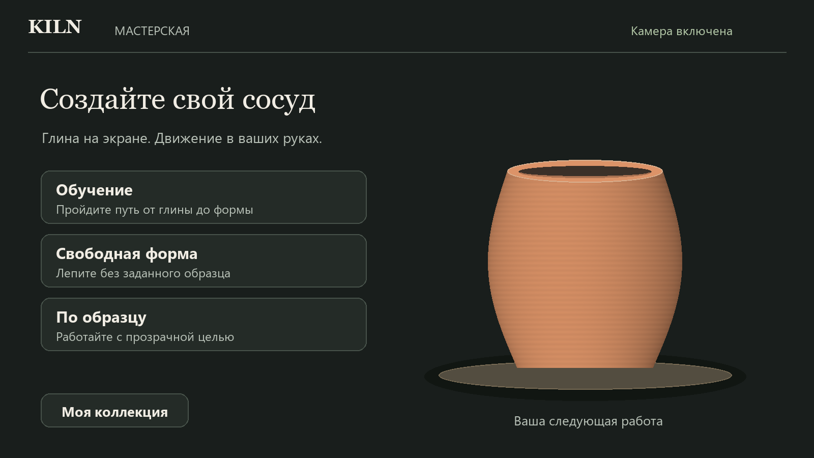
Proposed workshop menu with three clear starting paths and a ceramic object as the visual focus.

A clear opening screen
Present Обучение, Свободная форма and По образцу as three large choices. Each gets one explanatory sentence and a generous palm target. Place Моя коллекция below them. Avoid a rotating carousel: all modes should remain visible and selectable without following moving targets.

Camera setup as a short guided sequence
• Before permission, explain why the camera is needed and show one primary Начать button. Keep permission denial and model-loading failure separate, with a specific retry action.
• After permission, show a mirrored preview with a suggested hand area. Guide framing, lighting and hand visibility one requirement at a time. The camera image should be easy to reveal again later.
• Show separate states for no hands, one hand, both hands and ready. Pair each state with text; the player should know what is missing before calibration advances.
• After calibration, demonstrate palm dwell once on a harmless practice target. A completed ring should visibly activate that target before the menu becomes available.

A composed first impression
Use one slowly turning sample pot only while the menu is idle. Stop decorative motion during dwell or when reduced motion is enabled. Keep loading indicators honest: distinguish model loading, camera permission and calibration instead of displaying an invented percentage.
  - DESIGN PROPOSAL 04

Sculpting workspace
The proposed stage keeps confirmation controls outside the clay interaction area and disables them during sculpting.

One stable screen architecture
At desktop sizes, reserve approximately 60–65% of the useful screen for the clay and nearby hand motion. A compact left rail carries the current action and support status. The upper band carries one actionable instruction. The lower edge carries navigation and Готово. Keep these regions stationary when messages change.
• Free Mode shows the clay and concise technique assistance. Reference Mode adds a ghost profile and a compact shape comparison. Both use identical gesture feedback and finishing controls.
• Offer an optional low-opacity camera view and a clear camera-preview toggle. Keep hand landmarks aligned to the same mirrored coordinates as the clay; cosmetic perspective must never move the apparent contact plane.
• Show a soft contact patch at the active band and a small support marker at the supporting hand. Increase the response highlight only when geometry actually changes.

Protected actions
During activation, contact or deformation, dim and disable Готово and restart. Keep their positions stable so the layout does not jump. Explain the temporary state with a short label such as Отведите руки от глины. After reliable disengagement, restore the controls and start any new dwell from zero. Keep an accessible route back to the workshop.
Once Готово is selected, freeze the form and enter glazing. Neither raised hands nor an incidental movement should trigger this transition. A terminally damaged vessel should offer restart instead of finishing.
  - DESIGN PROPOSAL 05

Tutorial and reference guidance
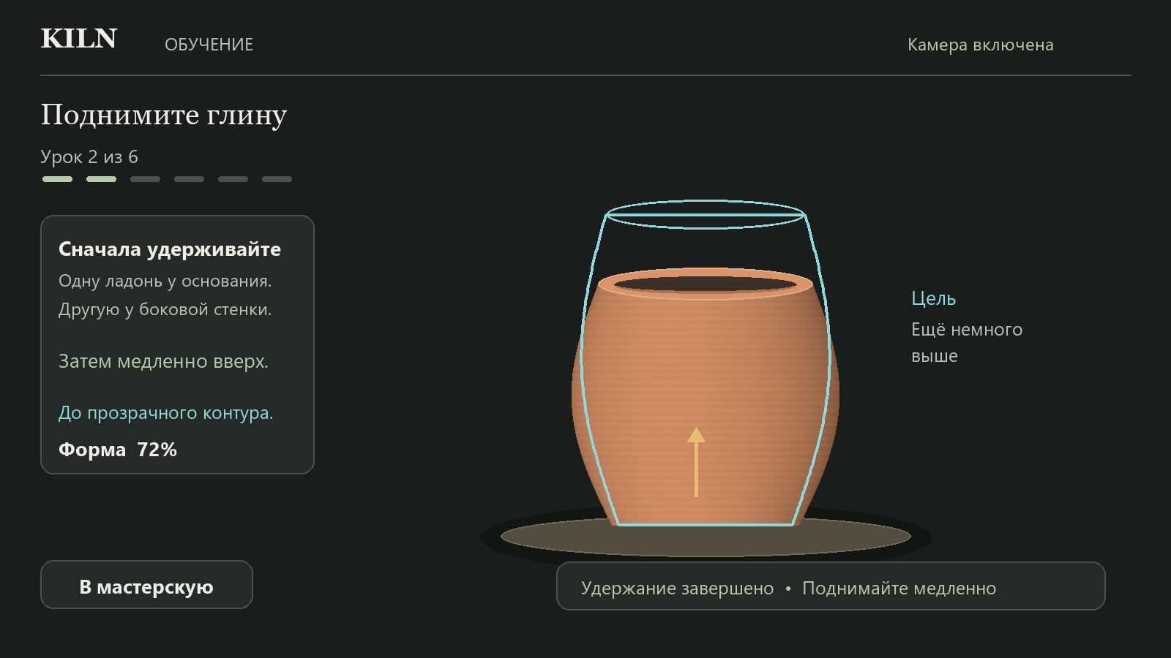
Proposed lesson layout with a persistent target and a clearly separate gesture preparation message.

Teach an observable result
Every working lesson phase needs four coordinated elements: the current step, one hand instruction, a transparent target and a result message. Keep the target anchored in world space. Use a fine cyan outline and restrained translucent fill so the real clay remains readable when the two shapes overlap.
• For an opening task, include the intended inner radius and floor depth. An optional cutaway explains the cavity without hiding its rim. Label the safe thumb depth as approximately one phalanx, not a measured centimeter value.
• Show one largest remaining difference: a little higher, narrower at the middle, or a wider opening. Keep the overall shape match secondary and explain that it describes geometry, not tracking confidence.
• Use short hand diagrams with an active-hand accent and a support marker. They must work with either hand assignment. Keep lengthy instructions behind a Help control.

Completion and retry
Confirm a working phase only after its geometry passes validation. Briefly show Форма совпала and require the appropriate release between actions. After the final validated compression, display Обучение окончено prominently; there is no additional finishing pose. Offer a return to the workshop and a clear route to free practice.
For serious overshoot or damage, keep the failed geometry visible and explain the cause, correction and restart scope. If retry restarts the whole attempt, label it that way. Reserve progress space so new text never covers the vessel or pushes controls under the player’s hands.
  - DESIGN PROPOSAL 06

Hands gestures and feedback
The player needs to distinguish detection, contact, preparation and actual deformation at a glance. Represent these as separate visible states. A tracked hand outline alone must not suggest that it is changing the clay.
State | Visual response | Meaning
Tracked | Quiet hand outline and palm dot | The camera sees the hand
Contact | Small patch on the clay and support marker | The hand is in a valid interaction zone
Preparing | Amber segmented arc beside the active hand | A required hold is accumulating
Armed | Completed arc with a short movement cue | Begin the specified controlled movement
Deforming | Contact highlight and direct shape response | The geometry is changing now
Brief uncertainty | Dashed outline and pause symbol | Hold progress may pause; clay does not move
Lost | Visible instruction near the top of the stage | Reposition hands before work resumes
Released | Contact highlight disappears | The clay has disengaged

Two different progress indicators
Use a compact sage ring attached to the UI cursor for button dwell. Use an amber arc close to the active hand for pottery activation, with a label such as Удерживайте 3 секунды. Their location, label and shape should make them distinguishable even without color. Never use a completed activation ring as proof that a target shape has been reached.

Guidance that responds to the current action
• Lift: preserve the accepted base pose, show preparation, then a restrained upward cue. Brief fluctuations should visibly pause rather than appear to restart without explanation.
• Thumb: show the insertion point, current floor and safe-depth marker. A rejected fast push gets a speed message, without a misleading deformation effect.
• Opening: show the two finger points and a thin inner-radius guide. Compression gets a downward cue and a target-height marker.
• Exterior shaping: show inward pressure. On outward withdrawal, remove contact feedback immediately and tell the player to leave contact before starting a new stroke if needed.
Keep coaching visual, consistent with the requested removal of voice-over. Use restrained optional sound effects for contact and completion. Clear old instructions when the action or lesson changes, rate-limit warnings and give tracking failure priority over technique advice.
  - DESIGN PROPOSAL 07

Material response and failure presentation
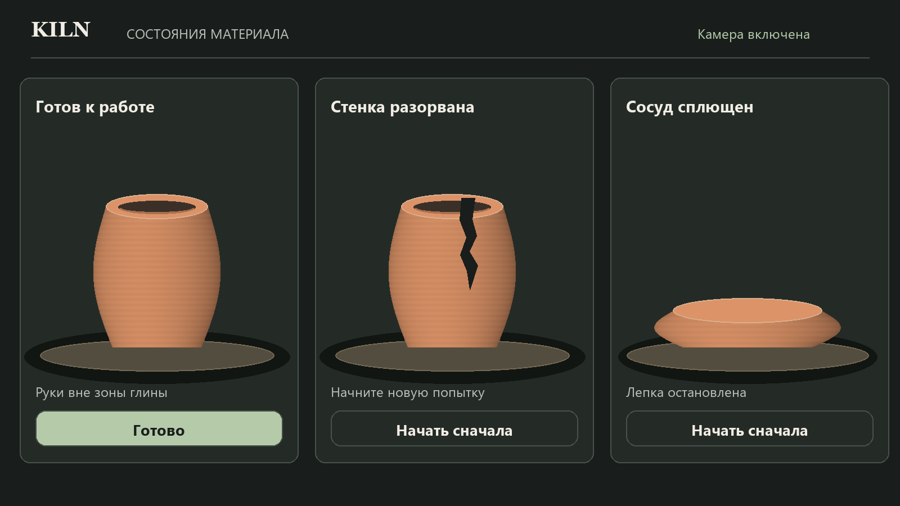
Proposed material states. The tear starts at the rim and runs downward; the pancake stays a distinct failure.

Make geometry readable
Outer pressure should visibly narrow the contacted band. Lift changes height, thumb travel changes cavity depth, opening increases inner radius and reduces wall thickness, and pressing lowers the rim. Reinforce these changes with lighting and contact feedback. Do not animate a false deformation over unchanged geometry.

Keep failure causes distinct
Cause | Visible consequence | Player response
Height at 20% of the initial value | Low, wide pancake with a closed cavity | Freeze sculpting and offer restart
Wall at 10% of original normalized thickness | Continuous jagged tear from the rim down to the weak band; keep overall height | Keep the break visible and offer restart
Bottom perforation | Visible floor hole and a matching cutaway marker | Identify excessive depth and offer restart
Tracking interruption | Paused hands and clay; no new damage | Ask the player to return hands to view

Use a warm red local marker to point at the actual damaged area. Avoid a full-screen red flash or a generic collapsing animation for every failure. Keep the cause on screen until restart, with a concise instruction such as Стенка разорвана. Начните сначала. Sounds should support the distinction without exaggerating the event.
  - DESIGN PROPOSAL 08

Glazing firing and the finished object
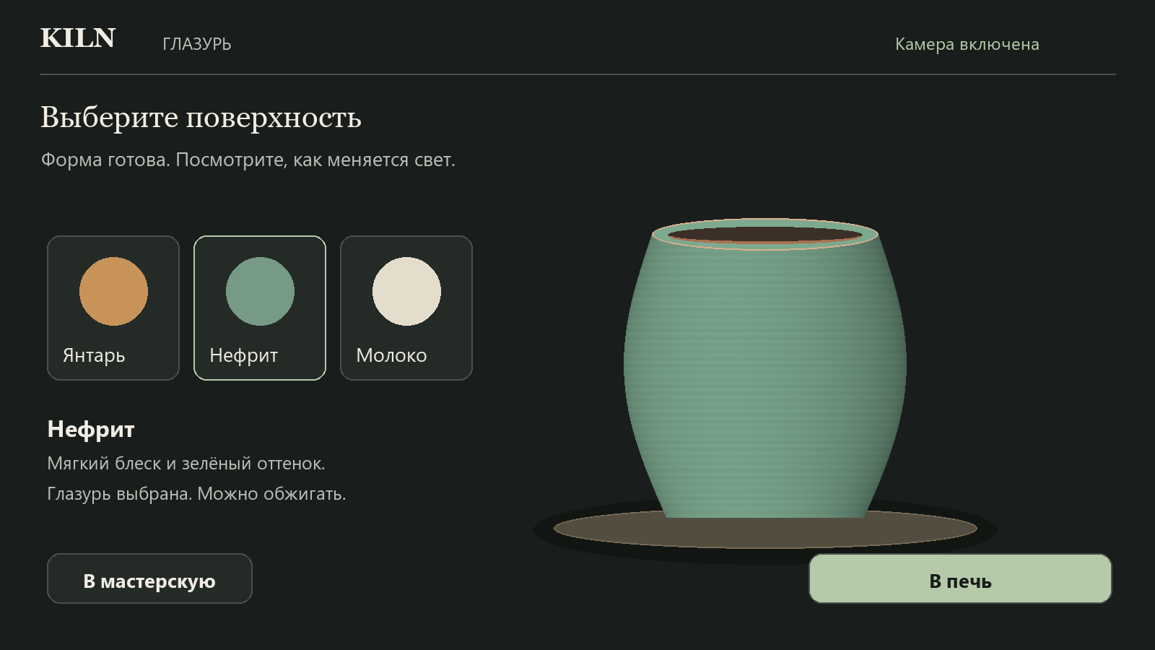
Proposed glazing screen. Material selection is deliberate and the firing action becomes available after a glaze is chosen.

A focused finishing sequence
Keep the path explicit: sculpting → Готово → glaze selection → В печь → firing → result. Present the three existing glazes as large ceramic swatches with names and a clearly marked selection. Update the vessel material immediately so the choice can be judged on its actual form.
• Use consistent lighting while comparing glazes. A selected swatch gets a border, checkmark and text confirmation; color alone is insufficient.
• Offer a dedicated 3D inspection view during a released shaping session and after finishing. Pause shaping while orbiting; restore the calibrated front view before hands can deform clay again.
• During firing, replace hand targets with a quiet kiln view and a clear progress state. Label the process as a game firing sequence. Avoid displaying a physically meaningful temperature curve unless the simulation actually models one.

A rewarding result screen
Reveal the finished pot against a simple exhibition backdrop. Show its name, mode, glaze and available export/save actions. In reference mode, explain the final geometry match with a compact breakdown. In free mode, emphasize the object and the player’s choices instead of imposing an unexplained score.
Keep visual celebration short and gentle: a material reveal, one light change and a soft completion sound are sufficient. Make mute and reduced motion effective here. Clearly state whether the piece has been saved locally or is available only for the current session.
  - DESIGN PROPOSAL 09

Collection and long term appeal
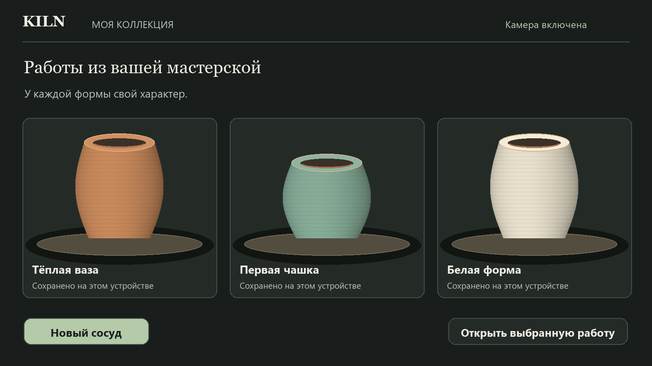
Proposed collection screen with consistent object lighting and clear local-storage expectations.

Treat each piece as a small exhibition
Use a simple grid with consistent thumbnail framing, generous spacing and quiet metadata. Allow the player to select a piece, inspect it, export its image and start another vessel. Optional naming should be offered after creation and remain editable later. Do not interrupt shaping with a naming dialog.
• Show glaze, creation date and mode when those fields are available. Reference pieces may also show the target name and final match. Keep saved data truthful to the current application.
• Use a readable empty state with one action: Создать первый сосуд. Explain local storage close to the shelf, and show a clear message if persistence is unavailable.
• If the shelf has a capacity limit, display it before older work is removed. Give export an obvious position so players can keep a record of a favorite object.

Future ideas to evaluate separately
A rotating collection pedestal, named practice series and a comparison of successive attempts could encourage return visits. A small set of curated vessel silhouettes could make reference practice feel intentional. Treat these as later design options that require their own behavior and storage decisions.
Keep an implementation boundary around accounts, cloud saves, social sharing and competition. Those features introduce new services and expectations. The initial design can feel complete through a coherent workshop, reliable interactions and a satisfying local collection.
  - DESIGN PROPOSAL 10

Responsive design and accessibility
Desktop landscape should be the primary camera-sculpting layout because it offers room for both hands and the vessel. Smaller screens need a deliberate arrangement that preserves the interaction area and the minimum comfortable size of controls.
Viewport | Proposed arrangement | Interaction requirement
1280 px and wider | Left guidance rail, central clay stage, edge actions | Keep the clay and both hand zones clear
900 to 1279 px | Narrower rail and shorter persistent guidance | Collapse supporting detail before shrinking essential text
Phone landscape | Compact top guidance, large stage and edge controls | No action panel over the rim or base
Phone portrait | Single short instruction above the stage; details in a sheet | Offer landscape guidance while keeping navigation accessible

Readable and reachable controls
• Use a proposed minimum 64 px primary dwell target, with generous spacing. Keep controls away from typical hand travel. Validate placement at the actual viewing distance rather than relying only on desktop screenshots.
• Retain click, keyboard focus and Enter/Space activation wherever a button can be selected by hands. Keep visible focus, accessible labels and a logical reading order.
• Pair every state color with text, an icon or a distinct outline. Verify text contrast against the final rendered background, including transparent panels over camera imagery.
• Support reduced motion, mute and readable Russian copy. Keep voice-over removed. Avoid warnings that require audio to understand. Announce phase changes once rather than on every tracking frame.

Camera framing and comfort
Provide an easy camera-preview control and a brief explanation of the mirrored view. Keep visual hand retention brief during a dropout, label it as uncertain, and never let it imply continued contact. Do not move important targets as the camera resizes; settle the layout before enabling dwell again.
On an unsuitable viewport or poor frame rate, reduce decorative effects and offer a clearer camera/framing suggestion. Do not invent confidence percentages. Show a confidence value only if the tracking pipeline supplies a meaningful, explained measure.
  - DESIGN PROPOSAL 11

Motion sound and frontend structure

Motion should explain state changes
Use quick 120–180 ms fades for panels and 180–240 ms state transitions as starting design values. Keep vessel motion directly tied to geometry. Avoid delayed visual easing that makes the clay appear to move after hands release. Camera and hand feedback need low latency; decorative polish must fit around that requirement.
• Menu objects may rotate slowly at rest. Pause their decorative motion during selection. Keep tutorial targets fixed.
• Use a brief contact glow for accepted pressure, a restrained preparation tick and a single completion cue. Do not play one sound per tracking frame.
• During a terminal failure, hold the damaged object and show the cause. Avoid camera shake, flashing or repeated impact effects.

Proposed component responsibilities
Organize the frontend around a workshop shell, clay stage, hand overlay, coaching area, tutorial panel, interaction-aware action bar, finishing view and collection view. The visual system should consume the existing controller state for phase, geometry, engagement, tracking, hints and failure cause. A renderer should never infer success from a button animation.
Centralize color, spacing, type, timing and elevation choices as design tokens. Use one button component for click, keyboard and dwell states. Clear obsolete coaching at each transition. Keep voice-over removed and preserve accessible status announcements.

Performance and asset discipline
Reuse materials and geometry buffers where practical. Keep textures modest, avoid expensive blur across the camera feed and update text only when its meaning changes. Prefer simple light and material adjustments before adding full-screen effects. Profile tracking, geometry updates and rendering together on the Acer Nitro 5 and a lower-powered test device.
Build a fallback visual tier that reduces shadows, texture detail and decorative animation. Keep silhouettes, damage markers, instructions and cursor feedback intact. Treat stable input response as the first performance goal; confirm the actual frame budget by measurement.

Assets to prepare
Prepare a KILN wordmark, a small outline icon set, five active/support hand diagrams, three glaze material previews, consistent collection thumbnails and restrained completion/error audio. Keep source vectors editable and require Cyrillic coverage for all UI fonts. Each asset should have a clear use in the player flow.
  - DESIGN PROPOSAL 12

Delivery priorities and acceptance review
Develop the redesign in small, reviewable stages. Keep the working palm navigation and the validated geometry rules as the baseline. Review each stage with synthetic tests and physical hands before expanding visual detail.
Stage | Proposed work | Review gate
1 Foundation | Tokens, typography, stage layout, buttons and coaching hierarchy | Readable at arm’s length; no clay or hand-zone obstruction
2 Interaction clarity | Contact, activation, release, tracking pause and disabled actions | No accidental Done activation; clear reason for every paused action
3 Guided creation | Targets, cavity guidance, geometry feedback, completion and retry | All lessons finish from the required shape, with synchronized text
4 Finishing | Glaze comparison, firing, result and local collection | Explicit Done gate; material and save state remain understandable
5 Polish | Lighting, motion, sound, responsive behavior and performance tiers | No tracking latency regression or inaccessible controls

A practical player review
• Enter by camera setup and palm dwell, complete the tutorial, and reach Обучение окончено without a mouse.
• Use all five pottery functions in Free Mode and Reference Mode with either active hand. Confirm tracking, contact, preparation and deformation remain distinguishable.
• Withdraw one or both palms, introduce brief fluctuations, and deliberately move too fast. Feedback should identify technique separately from tracking failure.
• Create a flat pancake, a local wall tear and a bottom hole. Each should look different, stop sculpting and provide a clear restart path.
• Finish deliberately, compare glazes, fire, save and export. Repeat with sound off, reduced motion, phone layouts and unavailable storage.

Recommended first design milestone
Approve the mineral-and-clay visual direction and the stable studio layout first. Then produce a detailed desktop studio mockup with idle, arming, shaping, released, tracking-paused and terminal-failure states. That single screen establishes the interface rules that every other mode should share.
The intended result is a professional pottery game whose visual polish makes the material easier to understand and the controls easier to trust. A strong clay presentation, consistent guidance and deliberate transitions can provide that identity without expanding the number of pottery functions.
  - DESIGN PROPOSAL 13

Wheel movement rim tears and 3D inspection
These approved additions make the vessel easier to read as a three-dimensional object. Keep every effect attached to the existing clay geometry and preserve the current hand controls, explicit Done gate and terminal damage rules.

A tear always begins at the rim
When the core reports a torn wall, open a narrow jagged notch through the rim, then extend that same continuous slit downward to the damaged section. Never create a floating crack or isolated hole in the middle of the wall. Keep neighboring clay and the overall vessel height intact. The front and inner wall must share one aligned opening, so the tear remains credible when the vessel is turned. Bottom perforation remains a separate floor failure.

A moving pottery wheel with restrained splatter
Rotate the wheel and vessel together around the vertical axis. Subtle wheel grooves, surface variation and small marks make rotation visible on a symmetrical form. Keep the hand contact plane and target silhouette fixed. Wheel rotation is presentation only; it must not create or accelerate deformation.
During fresh, accepted clay deformation, emit a small number of wet clay droplets outward from the contact height. Give them tangential motion, gravity and a short fade near the wheel. Use a fixed particle pool and stop emission on release, stale tracking, inspection, firing or permanent damage. Existing droplets may finish their short trajectories. Respect reduced motion by stopping decorative rotation and splatter.

Inspect the vessel from different angles
Provide an Осмотреть в 3D action when hands have released the clay, including during a lesson. Pause shaping and hide contact overlays. Let the player freely rotate the vessel through 360 degrees with mouse or touch drag, view above and underneath, and zoom. Hide the wheel during inspection so it cannot obscure the underside. Presets are optional shortcuts, not limits. Add keyboard rotation, zoom and reset, plus palm-dwell angle controls.
Use a dedicated inspection camera so the sculpting projection never drifts. Returning restores the exact calibrated front camera, clears dwell and input history, and waits for fresh observations. Phase changes, camera interruptions and navigation must also exit inspection cleanly. Keep inspection available for glazed and finished pieces; do not require an additional finishing gesture.

Acceptance review for these additions
• A damaged middle band produces one connected rim-to-band tear, with no isolated missing faces. Restart restores the intact mesh; pancake and bottom-hole results stay distinct.
• Wheel and clay rotate together. Splatter appears only during fresh deformation, respects reduced motion, stays bounded in count and never changes saved geometry.
• Inspect from front, side and above, zoom and reset. Geometry cannot change during inspection. Return and confirm hand contact still matches the clay without a jump.

